**DOCUMENTATION ON FOUR-CHANNEL EEG CIRCUIT**

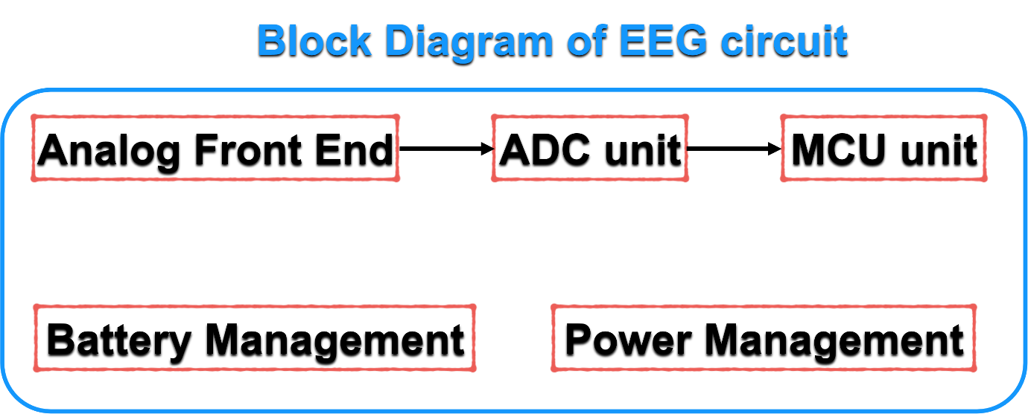

**Figure 1.** Proposed block diagram of EEG amplifier

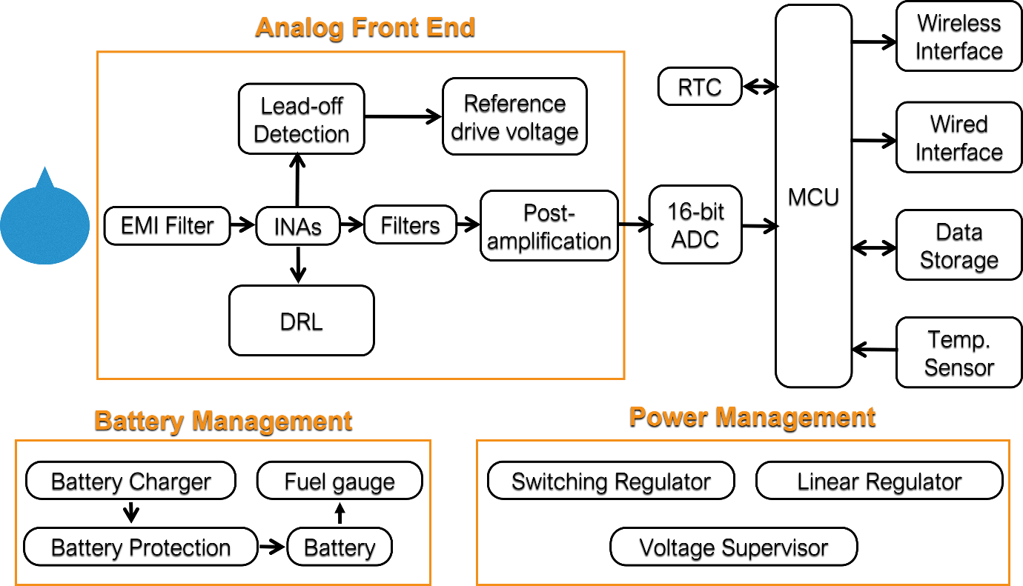

**Figure 2.** Proposed functional blocks of EEG amplifier

**Table 1**. Overview of required electronic components for the proposed hardware

|  |  |
| --- | --- |
| **COMPONENT** | **REMARKS** |
| INA | 1. AD 620- low-cost INA 2. INA333 – bit costly as compared to AD620 but comes with inbuilt EMI filters |
| Reference drive voltage | Reference drive voltage is required to provide a virtual reference voltage in the EEG circuit. It is possible to make circuit with general purpose op-amp but may suffer with minor voltage fluctuations. Dedicated ICs are available in the market but it might increase the overall cost of the EEG circuit. |
| Op-amps | Low-cost general-purpose op-amps are available (eg. LM324) but for better performance, high precision op-amps are required. (eg. LT1013, OP484) |
| ADC | Dedicated 16-bit sigma delta ADC (eg. ADS1115) or MCU inbuilt 12-bit ADC |
| Wireless interface | Low-cost BLE or WiFi |

**Table 2**. Survey on required electronic components and its availability in the market

|  |  |  |  |  |
| --- | --- | --- | --- | --- |
| **HARDWARE COMPONENTS** | | | | |
| **Sno.** | **Components** | **Specifications** | **Purpose** | **Price (for each item)** |
| 1 | Digital Storage Oscilloscope | 100MHz, Min. two channel | To test the EEG circuit, design analog filters, debug microcontroller signals etc. | <https://www.amazon.in/Siglent-Technologies-SDS1104X-U-Phosphor-Oscilloscopes/dp/B08PD3WKCZ/ref=cm_cr_arp_d_pl_foot_top?ie=UTF8>  48000 INR |
| 2 | AD620  (SMD) | Instrumentation amplifier | To design EEG front end stage | <https://www.electronicscomp.com/ad620-low-power-instrumentation-amplifier-ic-smd-package?search=ad620>  360 INR |
| 3 | OP484 IC | General purpose quad op amp | To design filter stage, DRL stage and buffer stage | <https://www.electronicscomp.com/op484-rail-to-rail-op-amp-ic-smd-package-india?search=op484>  400 INR |
| 4 | ADS 1115 | Four channels 16-bit sigma-delta ADC | To transmit analog EEG signals to Microcontroller | <https://www.dnatechindia.com/ads-1115-dgst-ic-analog-digital-converter-india.html>  300 INR |
| 5 | STM32  MCU | 80MHz speed, 1 MB Flash | 1. To interface ADC and BLE | 500 INR |
| 7 | Jumper wires and other electronic accessories | - | - | 5000 INR |
| 8 | Miscellene-ous | - | - | 10000 INR |

**Table 3.** Breakdown of the costs associated with the production of four channel EEG amplifier

|  |  |  |
| --- | --- | --- |
| **Component** | **Quantity** | **Cost (INR)** |
| INAs | 4 | 1600 |
| OP484 | 6 | 2400 |
| ADS115 | 1 | 300 |
| STM32 | 1 | 500 |
| BLUETOOTH | 1 | 300 |
| EXTRAS | - | 500 |
| **TOTAL (For each amplifier)** | | **5600** |